

Individual Project – Stock Management System

INDIVIDUAL ASSIGNMENT

COMP40003

**Software Development & Application Modelling– 02**

**CF2321COM**

**Prepared by:**

**Lithira Silva – CB012023**

**Date of submission:**

**29/09/2023**

**Instructor:**

**Dr. Upul Rathnayake**

Contents

Table of figures 3

Test Case Table 4

Diagrams 5

Activity diagrams 5

Sequence diagrams 7

Class diagram 9

UML diagram 10

# Table of figures

Activity Diagram 1 5

Activity Diagram 2 6

Sequence diagram 1 7

Sequence diagram 2 8

Class diagram 1 9

UML diagram 1 10

# Test Case Table

|  |  |  |  |  |  |
| --- | --- | --- | --- | --- | --- |
| **Test Case** | **Test Case Description** | **Test Data** | **Expected Result** | **Actual Result** | **Pass/Fail** |
| Test 1 | Insert a new item with unique stock code and name | Stock Code: "1", Stock Name: "af", Stock Quantity: 10 | Successfully added | Successfully added | Pass |
| Test 2 | Insert a new item with duplicate stock code | Stock Code: "1", Stock Name: "wd", Stock Quantity: 20 | An item with the same code or name already exists. | An item with the same code or name already exists. | Pass |
| Test 3 | Insert a new item with duplicate stock name | Stock Code: "2", Stock Name: "af", Stock Quantity: 30 | An item with the same code or name already exists. | An item with the same code or name already exists. | Pass |
| Test 4 | Load and display items from an empty database | No test data required | The DataGridView should be empty. | The DataGridView is empty. | Pass |
| Test 5 | Load and display items from a database with existing data | Insert a few items into the database before running this test. | The DataGridView should display the existing items. | The DataGridView displays the existing items. | Pass |

# Diagrams

## Activity diagrams

Use case 1

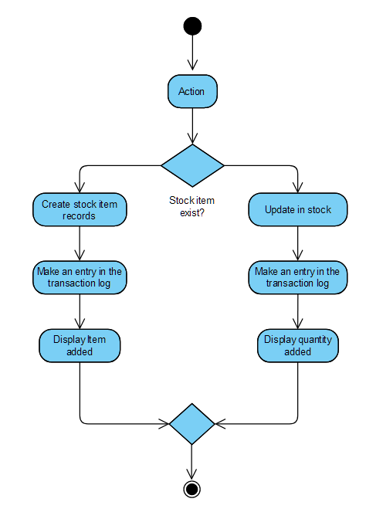

Activity Diagram 1

Use case 5

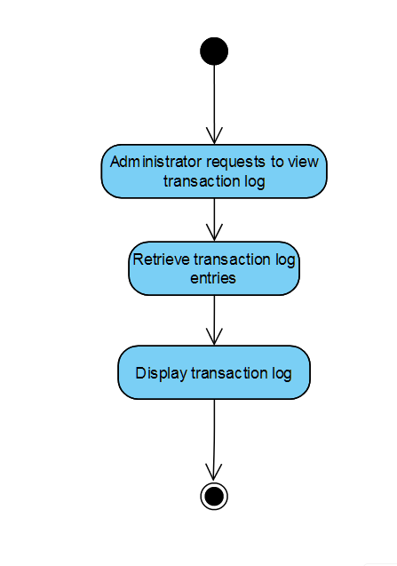

Activity Diagram 2

## Sequence diagrams

Use case 1

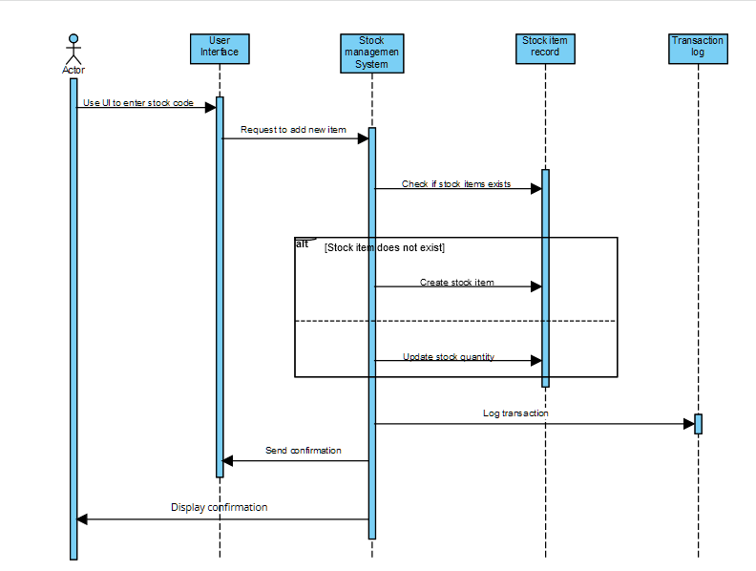

Sequence diagram 1

Use case 5

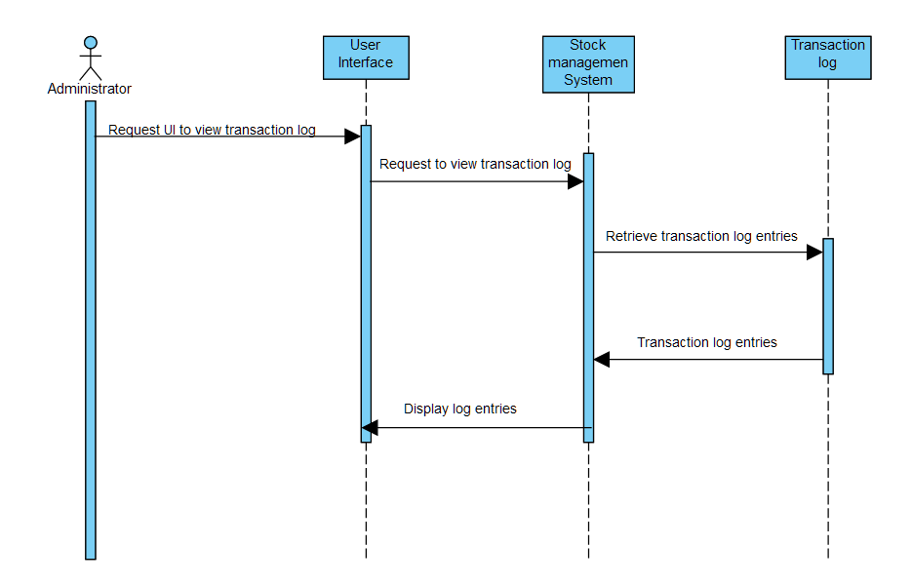

Sequence diagram 2

## Class diagram

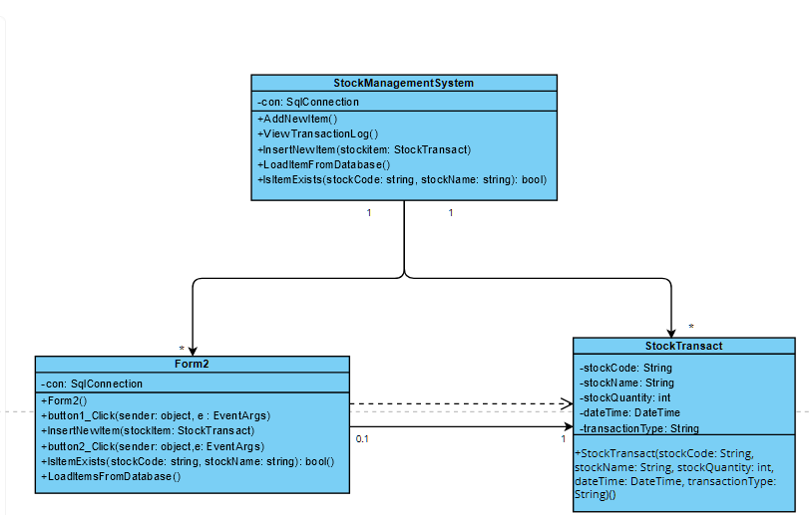

Class diagram 1

## UML diagram

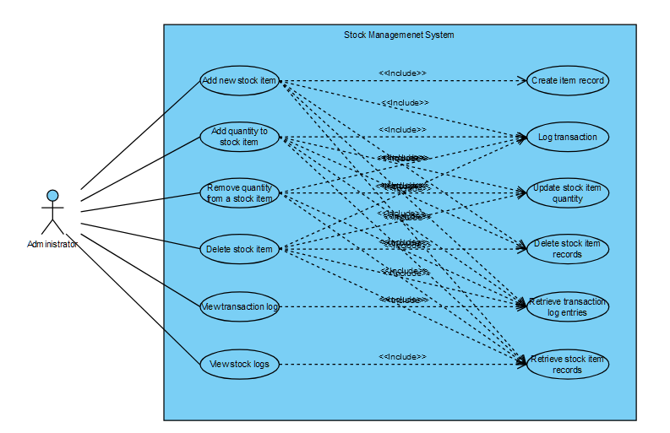

UML diagram 1